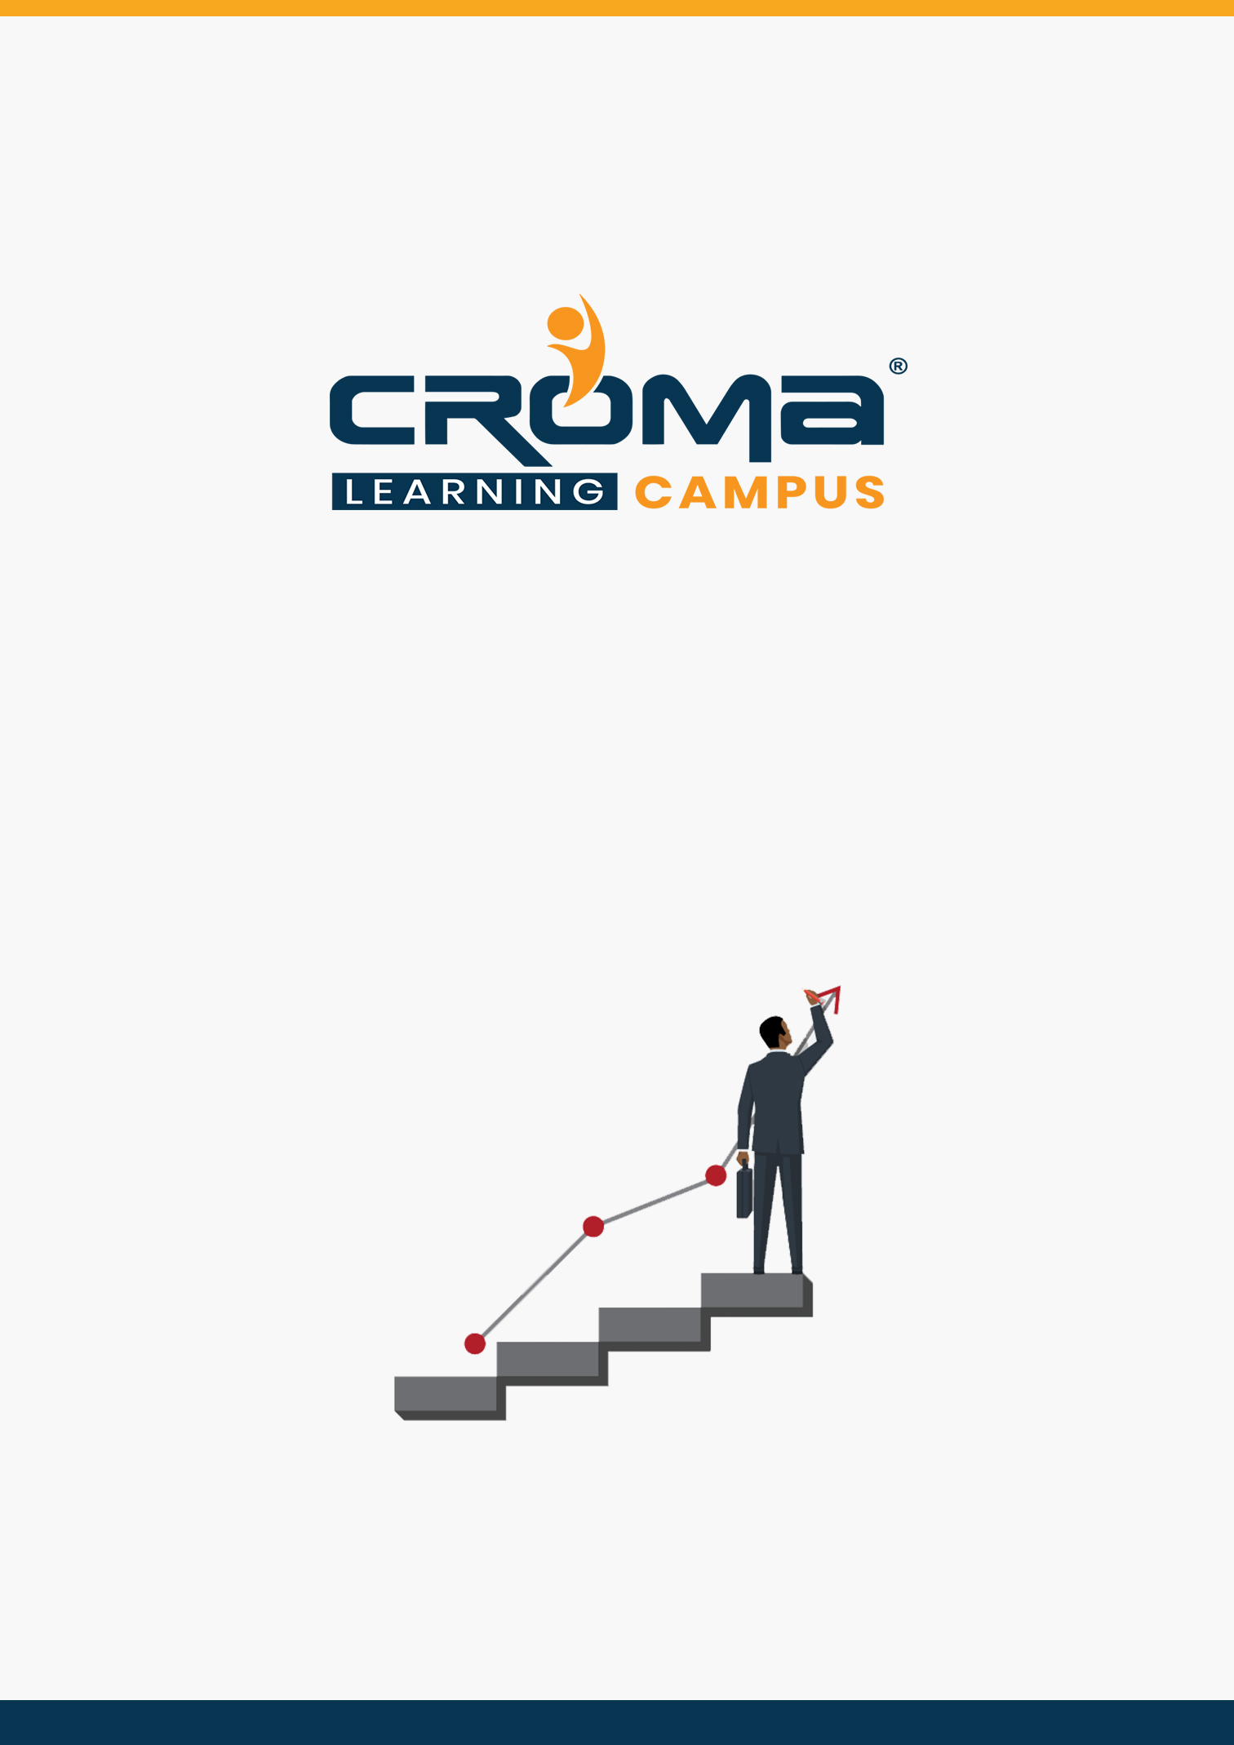

**SAP FICO Training Curriculum**

**STRUCTURE**

**www.cromacampus.com | helpdesk@cromacampus.com | +91-120-4155255**

**SAP FICO Training Curriculum**

*“Augment your existing skills or develop new expertise for SAP financial management solutions with our project-based SAP FICO training.”*

**Course Objectives:**

* Configuration and Implementation for SAP FICO module
* Requirements gathering for the Business Record to Report process cycle
* SAP Business analysis to improve financial activities
* Hands-on experience with SAP system
* Be able to take SAP FI Certification exam
* Be able to work as both SAP End-User and Consultant
* Understand how a required business process runs on SAP
* Integration of SAP FICO with SAP MM and SAP SD

**Course Description:**

SAP has multiple modules and SAP FICO is one of the proven finance modules that help to coordinate, monitor, and optimize all processes within an organization. The main objective of this module is to help information managers and decision-makers where the organization’s money is being spent. It does not obey any legal restriction but considered a vital internal cost accounting tool.

Our SAP FICO (Finance and Controlling) training at Croma Campus aims at providing comprehensive knowledge of SAP Finance and Controlling concepts in-depth with multiple examples and real-world scenarios. Our training program is designed in such a way that it will help you to master all functionalities and configurations available within the module. Also, it will help you to gain sufficient knowledge to appear for the SAP FICO exam and become an SAP FICO consultant by applying to multiple job openings in the same domain.

This SAP Controlling Course is intended for:

* SAP FICO Consultants / Managers / End Users
* Anyone aspiring to become SAP FICO Consultant or Manager
* SAP & ERP Professionals
* Business Analysts & Consultants
* Financial Analysts & Consultants
* Project Managers & Supervisors
* Accountants & CAs (Chartered Accountants)
* Anyone aspiring for a career in SAP

All the Best!

**Course Content:**

**SAP FI (Financial Accounting) Fundamentals**

**Module 1: Introduction**

* ERP Concepts
* SAP FICO Basic Concepts
* Finance Overview
* General Ledger Accounting
* Accounts Receivable
* Accounts Payable
* Bank Accounts
* Role of SAP Consultant
* Why SAP is in demand?
* Finance Overview: Transaction, Accounts and Accounting

**Module 2: General Settings**

* Nature of Accounting Information:
  + Accounting Concepts and Conventions
  + Accounting Standards
* Understanding/Preparation of Financial Statements:
  + Trial Balance
  + Profit and Loss account
  + Balance Sheet
  + Financial Reporting in India.
* Financial Statement Analysis:
  + Comparative Statements
  + Common Size Statement
  + Trend percentage analysis
  + Accounting Ratio Analysis
  + Fund Flow analysis
  + Cash Flow analysis.
* Creation of General Ledger Master (with and without reference)
* Display/Change/Block/Unblock of general ledger master
* Document Entry posting normal postings posting with reference
* Display and change of documents
* Display of GL balances and Line items
* Parked documents & hold documents
* Creation of Sample Document and posting
* Defining recurring entry document and posting
* Creation of account assignment model and posting
* Configuration of line layouts for display of GL line items
* Reversal of individual documents, mass reversal, reversal of cleared items and reversal of accrual and deferral documents
* Defining Exchange Rate types and Translation ratios
* Define Exchange rates & posting of foreign currency transactions
* Interest calculations on term loans

**Module 3: Document**

* Budgeting:
  + Budgets and Budgetary control
  + Principles and Methods
  + Preparation/Types of Budgets
  + Flexible Budget
  + Cash Budget
  + Master Budget
  + Zero Based Budgeting
  + Problems.
* Define Document Types and Number Ranges

**Module 4: Account Group & Retained Earning Account**

* Management Accounting:
  + Costing- Utility of costing elements
  + Cost Sheet Problems
  + Inflation Accounting
  + Human Resource Accounting
  + Depreciation Methods and Accounting.
* Define Account Group and Retained Earning Account

**Module 5: Field Status Variant**

* Volume Profit Analysis and Cost Control:
  + Marginal costing,
  + Cost-Volume Profit Analysis
  + Break Even Analysis
  + Applications and Limitations
  + Problems
* Standard Costing:
  + Maintain Field Status Variant
  + Assign Field Status Variant to Company Code

**Module 6: Tolerance Group**

* Tolerance Group for GL Accounts
* Tolerance Group for Employees
* Assigning Users to Tolerance Groups

**Module 7: Other Basic Steps**

* Enable Fiscal Year Default
* Enable Default Value Date
* Check Company Code settings in Global parameters

**Module 8: Other in GL**

* GL Master Creation
* Journal Entry Posting

**Module 9: Blocking of an GL Account**

* Nature and Scope of Financial Management:
  + Financial Objectives
  + Impact of Financial and Economical
* Environment on Financial Management:
  + Time Value of Money including Pension Funds
  + Computation of EMI
  + Annuity & Annuity Due.
* Funds Flow Analysis:
  + Cash Flow Statement and its Interpretation (AS-3)
  + Financial Statement Analysis
  + Ratio Analysis
  + Time Series
  + Common Size Statements
  + Du Pont Analysis.
* Unblocking of an GL Account
* Changing of GL Master
* Display Changes/What Changes/how it was done
* Parking of an account
* Releasing the parking document by changing the amount
* Releasing the parking document by deleting the document
* Difference between Park and Hold documents
* How to see an Account Balance

**Module 10: Reference Documents**

* Sample document
* Account Assignment Model
* Recurring Entries

**Module 11: Reversal of Document**

* Normal Reversal/Individual Reversal
* Mass Reversal
* Reversal of the Reversal

**Module 12: Open Item Management**

* Full Clearing
* Partial Clearing
* Residual Clearing

**Module 13: Accounts Receivable (AR)**

* Accounts Receivable (AR)

**Module 14: Settings in AR**

* Planning for Sources of Finance (Domestic and International):
  + Capital Structure
  + Net Income Approach
  + Net Operating Income Approach
  + Traditional Approach and MM Approach
* Cost of Capital:
  + Basic settings for ERP
  + Cost centre accounting
  + Profit centre accounting
  + Variance analysis and reporting
  + EBIT – EPS Analysis
  + Capital Gearing/Debt-Equity Ratio
  + Generation of Internal Funds.
* Account Group Creation
* Field Status
* No. Range Group and No. Ranges
* Assigning No. Range Group to Account Group
* Tolerance Group for Customers
* GL Accounts and Customer Master Creations
* Document Types and No. Ranges
* Posting Keys
* Invoice Posting
* Incoming Payment
* Clearing Open Items

**Module 15: Down Payment**

* Down Payment
* Establishment between Recon a/c and Alternative Recon a/c
* Down Payment in Short-Cut Method

**Module 16: Vendor Credit Memo**

* Correspondence

**Module 17: Special & Important Topics**

* Capital Budgeting
* Conventional and DCF Methods
* Inflation and Capital Budgeting
* Risk Analysis and Capital Budgeting-Certainty Equivalent Factor
* Risk Adjusted Discounting Rate
* Decision Tree
* Independent and Dependent Risk Analysis
* Replacement Decisions
* Sensitivity Analysis
* Basic International Capital Budgeting.
* Sales Tax
* Clearing Outstanding between Customer and Vendor
* Cash Discount
* Integration between FI and MM
* Integration between FI and SD
* Financial Statement Version

**Module 18: Asset Accounting (AA)**

* Retained Earnings Vs. Dividend Decision
  + Gordon Model
  + Walter Model
  + MM Approach
  + Lintner Model
* Planning of Funds through Management of Assets - Fixed and Current
  + Sustainable Growth Rate.
  + Working Capital Management
  + Management of Cash (Various Theoretical Models)
  + Inventories (Including Risk Analysis) and Receivables
  + Operating Cycle.
* Chart of Depreciation
* Account Determination
* Screen Layout
* Asset Master Creation
* Asset Class
* Depreciation Keys etc.
* Acquisition of Asset
* Asset Sale
* Scrapping of an Asset
* Transfer of Asset

**Module 19: Reports & Management Information System**

* GL Reports
* AR Reports
* AP Reports
* AA Reports
* MIS

**SAP Controlling (CO) Fundamentals**

**Module 20: Controlling area**

Controlling area or simply called costing and also called management accounting is an internal application of SAP which is basically used to control the cost of an organization.

* Concept of controlling area in SAP
* Controlling area same as company code VS. cross company code controlling area
* How values flow from finance into controlling?
* Different component of controlling area
* Master data in controlling
* What is plan data and actual data?
* What is variance in controlling?
* What is version in SAP?
* Hierarchy concept in SAP controlling

**Module 21: Cost Elements**

* What is cost element in controlling?
* Different type of cost element
* Primary and secondary cost element
* Difference between primary and secondary cost element
* Different category of primary and secondary cost element
* Use-purpose of primary and secondary cost element
* Different method of creation of cost element
* What is Default setting of cost element?
* What is cost element group?
* Why cost element group is maintained?
* How to display a list of all cost element?
* Cost element reports

**Module 22: Cost Center**

* What is cost center?
* Use of cost center in SAP
* What is standard hierarchy?
* What is cost center hierarchy?
* Cost center master data – cost center, activity type and statistical key figure
* Activity type of cost center
* Cost centre posting and reports
* What is real and statistical posting?
* Cost center reports

**Module 23: Profit Center**

* What is profit center?
* Why profit center is maintained?
* How value flow in profit center?
* Posting in profit center
* Profit center reporting

**Module 24:** **Placement Guide**

* Tips to clear an Interview
* Common Interview questions and answers
* SAP FICO Interview Questions and Answers
* Resume Building Guide
* Attempt for SAP FICO Global Certification Exam
* Start applying for Jobs